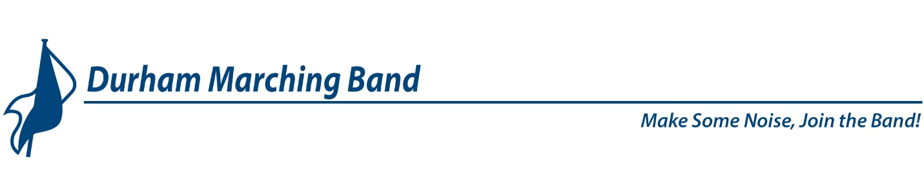 December 2018

The Future of the Durham Marching Band

Last April, members and advisors of the Durham Girls Alumni Band met to discuss the future of the band.
The DGAB had enjoyed a great six-year run, beginning in the Spring of 2012 (when the band was formed to celebrate Durham’s Homecoming that year). Originally, the band members were mostly alumni of the previous Durham Girls bands, and over time, new recruits replaced those who left, and the band performed in parades and concerts all over Grey Bruce and as far afield as Milton.
By the Spring of 2018, things were slowing down. At that point, the band was faced with very low membership, and very low morale. It was time to make some tough decisions.
Through surveys and several meetings in April and May, the Durham Girls Alumni Band made the following decisions:
- To rename the band and invite all genders to be part of it.
- Continue through to the end of 2018 and perform at as many Durham events as possible.
- Redouble our Recruitment efforts including advertising, social media, school visits, demo events and community-minded PR efforts
- Assess our progress at the end of 2018 and decide if there is a future for the band going forward.

It’s been quite a year! Here are some highlights of what’s happened since the end of May:
- We renamed and rebranded the band to be the Durham Marching Band. This required permission from the Municipality of West Grey, uniform changes (both summer and winter), a new banner and bass drum decals, and a great deal of advertising of all kinds.
- We held a total of 12 Pop-Up Practices, as well as a demo tent on Canada Day, and a promo at Hanover’s Registration night, to encourage recruitment and increase public awareness.
- We launched a website, a Facebook page, and Twitter and Instagram accounts for the band.
- We performed at Durham Loves Canada, the Durham Fall Fair, the Terry Fox Run, Durham’s Remembrance Day ceremony, Christmas parades and concerts in Markdale, Durham, Hanover, Neustadt, and Christkindl, and plan to perform at the Owen Sound Attack hockey game on January 2nd, 2019.
- Band membership has increased from 12 members to 32 members.

The Durham Marching Band still has challenges to meet:
- Availability – Even with our increased membership, availability for practices and performances is still a huge problem. Many invitations have been declined due to lack of availability and commitment.
- Commitment – The commitment level of some band members and advisory committee members is low, which adds to the workload of others.
- Communication – Communications at all levels need improvement. Quick responses to availability requests are essential, notifying others of changes made to music, marching or schedules is imperative, and communication within and between sections, and throughout the DMB needs to be better.
- Fundraising – No fundraising was done in 2018. Fundraising must be part of the future of the DMB and will require the participation of all members and advisors.
- Recruitment – This Spring, it was determined that the band needed 2 or more members for every position in order to be able to accept performance invitations and continue operating as a marching band. The membership of the DMB is very close to accomplishing that, but Recruitment is still an ongoing priority.

A great deal of time and effort has gone into all that’s been accomplished this year. Over the past few months, the Durham Marching Band has attracted an amazing 20 new members! Some of these people are experienced, and some are not, but all have brought their enthusiasm and talent to the group. The veterans of the group have done a fantastic job showing the rookies the ropes. Without your commitment, guidance and expertise, the band would not be the cohesive group that it is. And the Advisory Committee members have held it all together throughout the year. We should all feel very proud of ourselves.
Thank You to Everyone!
Given that we still have challenges ahead of us, we’d like to announce that the Durham Marching Band will be able to continue through 2019, and hopefully beyond.
Here’s to a great New Year!

Durham Marching Band Advisory Committee

